NBER WORKING PAPER SERIES

FISCAL DOMINANCE AND INFLATION TARGETING:

LESSONS FROM BRAZIL

Olivier Blanchard

Working Paper 10389
http://www.nber.org/papers/w10389

NATIONAL BUREAU OF ECONOMIC RESEARCH
1050 Massachusetts Avenue
Cambridge, MA 02138
March 2004

I thank Eliana Cardoso, Francesco Giavazzi, Ilan Goldfajn, Charles Wyplosz, and Santiago Herrera for many useful discussions. I also thank Ricardo Caballero, Arminio Fraga, Marcio Garcia, and Eduardo Loyo for comments. The paper has also benefited from discussions with staff members at the Central Bank, and the Ministry of Finance of Brazil. The data and programs used in the paper are available on my web site.The views expressed herein are those of the author and not necessarily those of the National Bureau of Economic Research.

©2004 by Olivier Blanchard. All rights reserved. Short sections of text, not to exceed two paragraphs, may
be quoted without explicit permission provided that full credit, including © notice, is given to the source.

Fiscal Dominance and Inflation Targeting: Lessons from Brazil
Olivier Blanchard
NBER Working Paper No. 10389
March 2004
JEL No. E5, F4, H6

ABSTRACT

A standard proposition in open-economy macroeconomics is that a central-bank-engineered increase in the real interest rate makes domestic government debt more attractive and leads to a real appreciation. If, however, the increase in the real interest rate also increases the probability of default on the debt, the effect may be instead to make domestic government debt less attractive, and to lead to a real depreciation. That outcome is more likely the higher the initial level of debt, the higher the proportion of foreign-currency-denominated debt, and the higher the price of risk.

Under that outcome, inflation targeting can clearly have perverse effects: An increase in the real interest in response to higher inflation leads to a real depreciation. The real depreciation leads in turn to a further increase in inflation. In this case, fiscal policy, not monetary policy, is the right instrument to decrease inflation.

This paper argues that this is the situation the Brazilian economy found itself in in 2002 and 2003. It presents a model of the interaction between the interest rate, the exchange rate, and the probability of default, in a high-debt high-risk-aversion economy such as Brazil during that period. It then estimates the model, using Brazilian data. It concludes that, in 2002, the level and the composition of public debt in Brazil, and the general level of risk aversion in world financial markets, were indeed such as to imply perverse effects of the interest rate on the exchange rate and on inflation.

Olivier Blanchard
Department of Economics
E52-373
MIT
Cambridge, MA 02139
and NBER
blanchar@mit.edu
A standard proposition in open-economy macroeconomics is that a central-bank-engineered increase in the real interest rate makes domestic government debt more attractive and leads to a real appreciation. If, however, the increase in the real interest rate also increases the probability of default on the debt, the effect may be instead to make domestic government debt less attractive, and to lead to a real depreciation. That outcome is more likely the higher the initial level of debt, the higher the proportion of foreign-currency-denominated debt, and the higher the price of risk.

Under that outcome, inflation targeting can clearly have perverse effects: An increase in the real interest in response to higher inflation leads to a real depreciation. The real depreciation leads in turn to a further increase in inflation. In this case, Fiscal policy, not monetary policy, is the right instrument to decrease inflation.

This paper argues that this is the situation the Brazilian economy found itself in 2002 and 2003.

In 2002, the increasing probability that the left-wing candidate, Luiz Inacio Lula da Silva, would be elected, led to an acute macroeconomic crisis in Brazil. The rate of interest on Brazilian government dollar-denominated debt increased sharply, reflecting an increase in the market's assessment of the probability of default on the debt. The Brazilian currency, the Real, depreciated sharply against the dollar. The depreciation led in turn to an increase in inflation.

In October 2002, Lula was indeed elected. Over the following months, his commitment to a high target for the primary surplus, together with the announcement of a reform of the retirement system, convinced financial markets that the fiscal outlook was better than they had feared. This in turn led to a decrease in the perceived probability of default, an appreciation of the Real, and a decrease in inflation. In many ways, 2003 looked like 2002 in reverse.

While the immediate danger has passed, there are general lessons to be learned. One of them has to do with the conduct of monetary policy in such an environment.

Despite its commitment to inflation targeting, and an increase in inflation from mid-2002 on, the Brazilian Central Bank did not increase the real interest rate until the beginning of 2003. Should it have? The answer given in the paper is that it should not have. In such an environment, the increase in real interest rates would probably have been perverse, leading to an increase in the probability of default, to further depreciation, and to an increase in inflation. The right instrument to decrease inflation was fiscal policy, and in the end, this is the instrument which was used.

The theme of fiscal dominance of monetary policy is an old theme, running in the modern literature from Sargent and Wallace [1981] “unpleasant arithmetic" to Woodford's “fiscal theory of the price level" [2003] (with an application of Woodford's theory to Brazil by Loyo [1999].) The contribution of this paper is to focus on a specific incarnation, to show its empirical relevance, and to draw its implications for monetary policy in general, and for inflation targeting in particular. The paper has two sections:

Section 1 formalizes the interaction between the interest rate, the exchange rate, and the probability of default, in a high-debt, high-risk-aversion economy such as Brazil in 2002-2003.

Section 2 estimates the model using Brazilian data. It concludes that, in 2002, the level and the composition of Brazilian debt, together with the general level of risk aversion in world financial markets, were indeed such as to imply perverse effects of the interest rate on the exchange rate and on inflation.

- A simple model

In standard open economy models, a central-bank-engineered increase in the real interest rate leads to a decrease in inflation through two channels. First, the higher real interest rate decreases aggregate demand, output, and in turn, inflation. Second, the higher real interest rate leads to a real appreciation. The appreciation then decreases inflation, both directly, and indirectly through the induced decrease in aggregate demand and output.

The question raised by the experience of Brazil in 2002 and 2003 is about the sign of the second channel. It is whether and when, once one takes into account the effects of the real interest rate on the probability of default on government debt, an increase in the real interest rate may lead, instead, to a real depreciation. This is the question taken up in this model, and in the empirical work which follows. The answer is clearly only part of what we need to know to assess the overall effects of monetary policy, but it is a crucial part of it. A discussion of the implications of the findings for overall monetary policy is left to the conclusion of the paper.

The model is a one-period model. The economy has (at least) three financial assets:

- A one-period bond, free of default risk, with nominal rate of return i.
Inflation, π, will be known with certainty in the model so there is no need to distinguish between expected and actual inflation, and the real rate of return r on the bond (in terms of Brazilian goods) is given by:

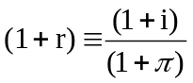

I shall think of r as the rate controlled by the central bank (the model equivalent of the Selic in Brazil).

- A one-period government bond denominated in domestic currency (Reals), with stated nominal rate of return in Reals of i^{R}.
Conditional on no default, the real rate of return on this bond, r^{R}, is given by:

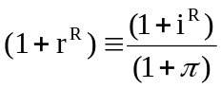

Let p be the probability of default on government debt (default is assumed to be full, leading to the loss of principal and interest). Taking into account the probability of default, the expected real rate of return on this bond is given by:
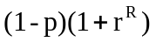

- A one-period government bond denominated in foreign currency (dollars),with stated nominal rate of return in dollars of i$.
Conditional on no default, the real rate of return (in terms of U.S. goods) on this bond, r$, is given by:

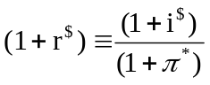

where stars denote foreign variables, so P¤ is foreign (U.S.) inflation.
Conditional on no default, the gross real rate of return in terms of Brazilian goods is given by:

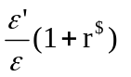

where ε denotes the real exchange rate, and primes denote next-period variables.
Taking into account the probability of default, the gross expected real rate of return on this bond is given by:
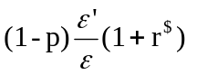

1.1 Equilibrium rates of return
We need a theory for the determination of r^{R} and r$ given r. I shall stay short of a full characterization of portfolio choices by domestic and foreign residents, and simply assume that both risky assets carry a risk premium over the riskless rate, so their expected return is given by:

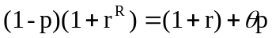 (1)

and
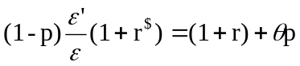 (2)

Both assets are subject to the same risk, and so carry the same risk premium. The parameter θ reflects the average degree of risk aversion in the market. The probability of default p proxies for the variance of the return. For empirically relevant, values of p, the variance is roughly linear in p, and using p simplifies the algebra below.

Note the two roles of the probability of default in determining the stated rate on government debt. First, a higher stated rate is required to deliver the same expected rate of return; this is captured by the term (1 - p) on the left in both equations. Second, if investors are risk averse, a higher expected rate of return is required to compensate them for the risk; this is captured by the term θp on the right in both equations.

1.2 Capital flows and trade balance
The next step is to determine the effect of the probability of default, p, and of the real interest rate, r, on the real exchange rate, ε. To do so requires looking at the determinants of capital flows.

Let the nominal interest rate on U.S. bonds be I*, so the gross expected real rate of return (in terms of U.S. goods) on these bonds is (1 + r*) ≡ (1 + i*) / (1 + π∗).

Assume foreign investors are risk averse, and choose between Brazilian dollar bonds and U.S. government dollar bonds, so capital flows are given by:

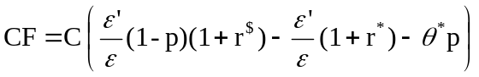 C’ >0

The First two terms are the expected rates of return on Brazilian and U.S. dollar bonds respectively, both expressed in terms of Brazilian goods. The third term reflects the adjustment for risk on Brazilian dollar bonds: The parameter θ* reflects the risk aversion of foreign investors, and p proxies, as before, for the variance of the return on Brazilian dollar bonds. The higher the expected return on Brazilian dollar bonds, or the lower the expected return on U.S. dollar bonds, or the lower the risk on Brazilian bonds, the larger the capital inflows.

Using the arbitrage equation between risk-free domestic bonds and domestic dollar bonds derived earlier, the expression for capital flows can be rewritten as:

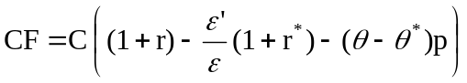

Whether an increase in the probability of default leads to a decrease in capital flows depends therefore on (θ - θ∗), the difference between average risk aversion and the risk aversion of foreign investors. If the two were the same, then the increased probability of default would be reflected in the equilibrium rate of return, and foreign investors would have no reason to reduce their holdings. The relevant case appears to be however the case where θ* > θ where foreign investors have higher risk aversion than the market, so an increase in risk leads both to an increase in the stated rate and to capital outflows. This is the assumption I shall make here.

A simple way of capturing this is to assume that θ and θ* satisfy:

θ = λθ*; λ ≤ 1 (3)

so the the average risk aversion in the market increases less than one for one with the foreign investors' risk aversion. Under that assumption, capital flows are given by:

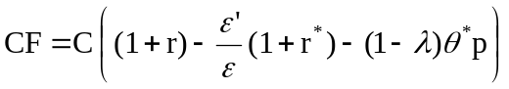

Turn now to net exports. Assume net exports to be a function of the real exchange rate:

NX = N(ε) N’ > 0

Then, the equilibrium condition that the sum of capital flows and net exports be equal to zero gives:

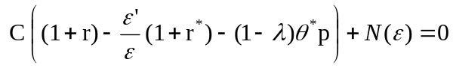

In a dynamic model, ε’ would be endogenously determined. In this one-period model, a simple way to proceed is as follows. Normalize the long run equilibrium exchange rate (equivalently the pre-shock exchange rate) to be equal to one. Then assume:

ε’ = ε^{η}

with η between zero and one. The closer η is to one, the more the future exchange rate moves with the current exchange rate, and by implication the larger the real depreciation needed to achieve a given increase in capital flows.

Replacing ε’ in the previous equation gives us the first of the two relations between ε and p we shall need below:

(4)

This First relation between the exchange rate and the probability of default is plotted in Figure 1.

[Figure 1. The exchange rate as a function of the probability of default.]

An increase in the probability of default increases risk. This increase in risk leads to an increase in the exchange rate - to a depreciation: The locus is upward-sloping. The slope depends in particular on the degree of risk aversion, θ*. Two loci are drawn in the figure: The flatter one corresponds to low risk aversion; the steeper one corresponds to high risk aversion.

For a given probability of default, an increase in the interest rate leads to a decrease in the exchange rate, to an appreciation - the standard channel through which monetary policy affects the exchange rate. To a first approximation, the vertical shift in the locus does not depend on risk aversion. The two dotted lines show the effects of an increase in the interest rate on the equilibrium locus.

1.3 Debt dynamics and default risk
The next step is to determine the effect of the real exchange rate, ε, and the interest rate, r, back on the probability of default, p. This requires us to look at debt dynamics.

Assume the government finances itself by issuing the two types of bonds we have described earlier, some in Real, some in dollars, both subject to default risk.

Denote by D$ the amount of dollar-denominated debt (measured in U.S. goods) at the start of the period. Given the current real exchange rate ε, the current real value (in Brazilian goods) of this dollar debt is D$ε. Absent default, the real value (again, in Brazilian goods) of the dollar debt at the start of next-period is (D$(1 + r$)ε’).

Denote by D^{R} the amount of Real-denominated debt (measured in Brazilian goods) at the start of the period. Then, absent default, the real value of this Real-denominated debt at the start of next period is D^{R}(1 + r^{R}).

Conditional on no-default, debt at the start of next period is thus given by:

D’ = D$(1 + r$)ε’ + D^{R}(1 + r^{R}) - X

where X is the primary surplus.

Using equations (1) and (2) to eliminate (1 + r$) and (1 + r^{R}), and equation (3) to replace θ by ¸λθ* gives:

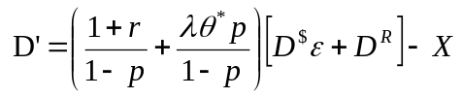

For convenience (so we can discuss composition versus level effects of the debt), define μ as the proportion of dollar debt in total debt at the equilibrium long-run exchange rate (normalized earlier to be equal to one), so μ ≡ D$/D, where D = (D$ + D^{R}). The above equation becomes:

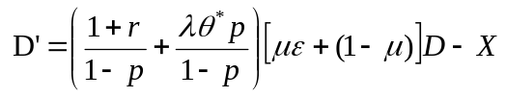

A higher probability of default affects next-period debt through two channels: It leads to a higher stated rate of return on debt so as to maintain the same expected rate of return; this effect is captured through 1/(1 - p). And, if risk aversion is positive, the higher risk leads to a higher required expected rate of return; this effect is captured through λθ*p.

The last step is to relate the probability of default to the level of debt next period.
If we think of the probability of default as the probability that debt exceeds some (stochastic) threshold, then we can write:

p = ϕ (D’) ϕ' > 0

and we can think of the function ϕ (.) as a cumulative probability distribution, low and nearly flat for low values of debt, increasing rapidly as debt enters a critical zone, and then flat again and close to one as debt becomes very high.

Putting the last two equations together gives us the second relation between the probability of default and the exchange rate we shall need below:

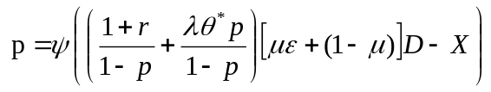 (5)

Note that p depends on itself in a complicated, non linear fashion. To explore this relation, Figure 2 plots the right- and the left-hand sides of the previous equation, with p on the horizontal axis, and both p and ϕ (.) on the vertical axis, for given values of the other variables, including the exchange rate. The left hand side, p, as a function of p, is given by the 45 degrees line. The shape of ϕ as a function of p depends on whether the underlying distribution has infinite or finite support.

[Figure 2. The probability of default as a function of itself]

- If it has infinite support, then the shape of ϕ is as shown by the locus AA". For any level of debt, there is a positive probability of default, how ever small. Thus, even for p = 0, ϕ is positive. As p increases, so does D’, and so does ϕ. As p tends to one, 1/(1 - p) tends to infinity, so does D’, and ϕ tends to one.

- If it has finite support, then the shape of ϕ is as shown by the locus OA'A". In this case, there is a critical value of next-period debt below which the probability of default is zero. So long as initial debt, the interest rate, and the primary surplus are such that next-period debt remains below this critical value, increases in p do not increase ϕ, which remains equal to 0. For some value of p, the probability of default becomes positive. And, as before, as p tends to one, ϕ tends to one.

This implies that there are typically three equilibria (B, C and A" in the case of infinite support, and O, C' and A" in the case of finite support.) (If debt is high enough, there may be no equilibrium except p = 1; I leave this standard case of credit rationing aside here.) Standard comparative statics arguments eliminate the middle equilibrium (C or C'). The equilibrium with p = 1 is present in any model and is uninteresting. I shall assume in what follows that the relevant equilibrium is the lower equilibrium (O or B) and that such an equilibrium exists. Under this assumption, we can draw the relation between p and ε implied by equation (5).

If there is no dollar debt (μ = 0), then the locus is horizontal: p may be positive but is independent of the exchange rate.

If there is dollar debt, then the locus is either flat (if the support is finite, and the exchange rate is such that next-period debt remains below the critical level), or upward-sloping (if the exchange rate is such that the probability of default becomes positive.) If it is upward-sloping, its slope is an increasing function of the proportion of dollar debt, and an increasing function of total initial debt. Figure 3 shows two loci, one with a flat segment, corresponding to low initial debt, the other upward-sloping and steeper, corresponding to higher initial debt.

The effect of an increase in the interest rate is then either to leave the probability of default unchanged (if next-period debt remains below the critical level), or to increase the probability of default. The effect is again stronger the higher the initial level of debt. Figure 3 shows the effects of an increase in the interest rate on each of the two loci.

[Figure 3. The probability of default as a function of the exchange rate.]

1.4 The effects of the interest rate on default risk and the real exchange rate
To summarize: The economy is characterized by two equations in p and ε, for given values of monetary and fiscal policies, r; r*; D, X and given parameters η, θ∗, μ, λ :

(6)

(7)

For lack of better names, call the first the “capital flow" relation, and the second the “default risk" relation.

The question we want to answer is: Under what conditions will an increase in the interest rate lead to a depreciation rather than to an appreciation?

From the two equations, the answer is straightforward: The higher the level of the initial debt, or the higher the degree of risk aversion of foreign investors, or the higher the proportion of dollar debt in total government debt, then the more likely it is that an increase in the interest rate will lead to a depreciation rather than an appreciation of the exchange rate.

This is shown in the three panels of Figure 4:

[Figure 4 a,b,c. Effects of an increase in the interest rate on the exchange rate]

- Figure 4a looks at the case where the government has no dollar debt outstanding, so the probability of default is independent of the real exchange rate, and the default risk locus is vertical (it was horizontal in Figure 3, but the axes are reversed here). It shows the equilibrium for two different levels of debt, and thus two different probabilities of default. From Figure 1, the capital flow locus is upward-sloping. The equilibrium for low debt is at A, the equilibrium for high debt is at B.
In this case, an increase in the interest rate shifts the capital flow locus down: A higher interest rate leads to a lower exchange rate. It shifts the default risk locus to the right: A higher interest rate increases the probability of default. The size of the shift is proportional to the initial level of debt. So the larger the initial debt, the more likely it is that the increase in the interest rate leads to a depreciation. As drawn, at low debt, the equilibrium goes from A to A', and there is an appreciation; at high debt, the equilibrium goes from B to B', and there is a depreciation.

- Figure 4b still looks at the case where the government has no dollar debt outstanding and the default risk locus is vertical. It shows the equilibrium for two different values of risk aversion, and thus two different slopes of the capital flow locus. In response to an increase in the interest rate, the capital flow locus shifts down; the size of the shift is approximately independent of the degree of risk aversion.
So, under low risk aversion, the equilibrium goes from A to A', with an appreciation. Under high risk aversion, the equilibrium goes from B to B', with a depreciation. Again, in this second case, the indirect effect of the interest rate, through the increase in the probability of default, and the effect on capital flows, dominates the direct effect of the interest rate on the exchange rate.

- Figure 4c compares two cases, one in which the proportion of dollar debt, μ is equal to zero, and one in which μ is high. The equilibrium for low dollar debt is at A, the equilibrium for high dollar debt is at B.
An increase in the interest rate shifts the capital flow locus down. It shifts the default risk locus to the right, and the shift is roughly independent of the value of μ. For the low value of μ, the equilibrium moves from A to A', with an appreciation. But for a high value of μ, the equilibrium moves from B to B', with a depreciation.

In short: high debt, high risk aversion on the part of foreign investors, or a high proportion of dollar debt can each lead to a depreciation in response to an increase in the interest rate.

All these factors were indeed present in Brazil in 2002. The next question is thus to get a sense of magnitudes. This is what we do in the next section.

A look at the empirical evidence

The purpose of this section is to look at the evidence using the model as a guide. More specifically, I estimate the two relations between the exchange rate and the probability of default suggested by the model, and look at whether, in conditions such as those faced by Brazil in 2002, an increase in the interest rate is likely to lead to an appreciation or, instead, to a depreciation.

The First step must be to obtain a time series for the probability of default, p. We can then turn to the estimation of the two basic equations.

2.1 From the EMBI spread to the probability of default
A standard measure of the probability of default is the EMBI spread, the difference between the stated rate of return on Brazilian dollar-denominated and U.S. dollar- denominated government bonds of the same maturity. But, clearly, the EMBI spread reflects not only the probability of default, but also the risk aversion of foreign investors. And we know that their degree of risk aversion (or its inverse, their “risk appetite") varies substantially over time. The question is whether we can separate the two and estimate a time series for the probability of default.

To make progress, go back to the capital flow equation and rewrite it as:

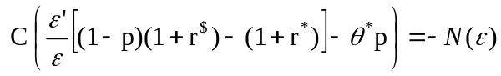

Invert C(.) and reorganize to get:

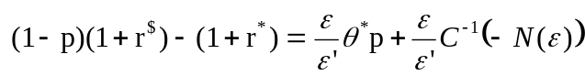
Define the Brazil spread as:

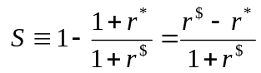

The previous equation can then be rewritten to give a relation between the spread, the probability of default, and the exchange rate:

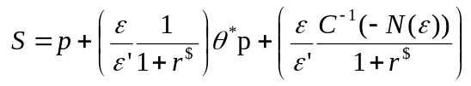 (8)

The interpretation of equation (8) is straightforward: Suppose investors were risk neutral, so θ* = 0 and C’ = ∞. Then S = p: The spread (as defined above, not the conventional EMBI spread itself) would simply give the probability of default the first term on the right. If investors are risk averse however, then two more terms appear. First, on average, investors require a risk premium for holding Brazilian dollar-denominated bonds. This risk premium is given by the second term on the right. Second, as the demand for Brazilian dollar-denominated bonds is downward-sloping, the rate of return on these bonds must be such as to generate capital flows equal to the trade deficit. This is captured by the third term on the right. If capital flows are very elastic, then changes in the rate of return required to generate capital flows are small, and this third term is small.

We can now turn to the econometrics.

A good semi-log approximation to equation (8), if θ* and p are not too large, is given by:

log S = log p + aθ* + u

where a = 1/(1 + r$), and u is equal to the last term in equation (8) divided by 1 + C⁻¹(.)/(1 + r$).

- We clearly do not observe θ*, but a number of economists have suggested that a good proxy for θ* is the Baa spread, i.e the difference between the yield on U.S. Baa bonds and U.S. T-bonds of similar maturities. (In other words, their argument is that most of the movements in the Baa spread reflect movements in risk aversion, rather than movements in the probability of default on Baa bonds). If we assume that the Baa spread is linear in θ*, this suggests running the following regression:

log S = c + b Baa spread + residual

and recovering the probability of default as the exponential value of c plus the residual. This however raises two issues:

- First, the residual gives us at best (log p + u), not (log p). Approximating the log probability in this way will thus be approximately correct only if u is small relative to changes in probability. This will in turn be true if capital flows are relatively elastic. As I see no simple way out, I shall again maintain this assumption.

- Second, the estimate of b, and by implication, the estimate of (log p) will be unbiased only if the Baa spread and the residual are uncorrelated. This is unlikely to be true. Recall that the residual includes the log of the probability of default. As we have seen in the model earlier, an increase in risk aversion, which increases the Baa spread, is also likely to increase the probability of default. Again, I see no simple way out, no obvious instrument. As the effect of risk aversion on the probability of default is non linear however, and likely to be most relevant when θ* (and so, by implication, the Baa spread) is high, this suggests estimating the relation over subsamples with a relatively low value of the Baa spread. I shall do this below.

Table 1. Estimating the probability of default.

 | Sample | (t-stat) | DW | ro | 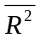
OLS | 1995:2 2004:1 | 0.37 (9.5) | 0.34 |  | 0.46
AR1 | 1995:2 2004:1 | 0.31 (3.6) |  | 0.84 | 0.89
AR1 | Baa spread < 3.0% | 0.16 (1.7) |  | 0.85 | 0.89
AR1 | Baa spread < 2.5% | 0.15 (0.9) |  | 0.88 | 0.90

Table 1 reports the results of regressions of the log spread on the Baa spread, using monthly data. All data here and below, unless otherwise noted, are monthly averages. The spread is defined as described above, based on the spread of the Brazilian C{bond over the corresponding T-bond rate. The Baa spread is constructed as the difference between the rate on Baa bonds and the 10-year Treasury bond rate.

The First line reports OLS results for the longest available sample, 1995:2 to 2004:1.
The estimated coefficient is equal to 0.37. The change in exchange and monetary regimes which took place at the start of 1999, with a shift from crawling peg to floating rates and inflation targeting, raises the issue of subsample stability: One might expect this regime change to have modified the relation of the Brazil spread to the Baa spread; results using the smaller sample 1999:1 to 2004:1 give however a nearly identical estimate for b, so I keep the longer sample.

The second line shows the results of AR(1) estimation. The estimated coefficient is nearly identical. With simultaneity bias in mind, the next two lines look at two subsamples. The First eliminates all months for which the Baa spread is above 3.0%; this removes all observations from 2001:9 to 2001:11, and from 2002:6 to 2003:3. The second eliminates all months for which the Baa spread is above 2.5%; this removes all observations from 1998:10 to 1999:1 (the Russian crisis), and from 2000:9 to 2003:4. As we would expect, the coefficient on b decreases, from 0.32 to 0.16 in the First case, and to 0.15 in the second case.

In what follows, I use a series for p constructed by using an estimated coefficient = 0:16. (Results below are largely unaffected if I use one of the other values for in Table 1 instead.) Figure 5 shows the evolution of the EMBI spread, and the constructed series for p. The two series move largely together, except for mean and amplitude. The main difference between the spread and probability series takes place from early 1999 to early 2002. While the spread increases slightly, the increase is largely attributed to the increase in risk aversion, and the estimated probability of default decreases slightly during the period.

[Figure 5. The evolution of the EMBI spread, and the estimated probability of default.]

2.2 Estimating the capital flow relation
We can now turn to the estimation of the two relations between the exchange rate and the probability of default.

The First is the “capital flow" relation, which gives us the effect on the exchange rate of a change in the probability of default. A good semi-log approximation to equation (6) is given by:

log ε = a – b (r – r*) + c (pθ*) + u_{ε} (9)

The real exchange rate between Brazil and the United States is a decreasing function of the real interest differential, and a decreasing function of the risk premium -- the product of the probability of default times the degree of risk aversion of foreign investors. The error term captures all other factors.

That there is a strong relation between the risk premium and the real exchange rate is shown in Figure 6, which plots the real exchange rate against the risk premium for the period 1999:1 to 2004:1 (the period of inflation targeting and floating exchange rate). The real exchange rate is constructed using the nominal exchange rate and the two CPI deflators. The risk premium is constructed by multiplying estimated p and θ* from the previous subsection. (Using the EMBI spread instead of pθ* would give a very similar picture). The two series move surprisingly together.

[Figure 6. The real exchange rate and the risk premium]

Turning to estimation, I estimate two different specifications of equation (9). The First uses the nominal exchange rate and nominal interest rates; the second uses the real exchange rate and real interest rates. The only justification for the nominal specification is that it involves less data manipulation (no need to choose between deflators, or to construct series for expected inflation to get real interest rates).

Results using the nominal specification are presented in the top part of Table 2. The nominal exchange rate is the average exchange rate over the month. The nominal interest rate differential is constructed as the difference between the average Selic rate and the average federal funds rate over the month, both measured at annual rates.

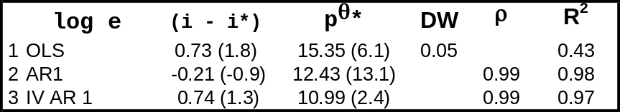
Table 2. Estimating the capital flow relation
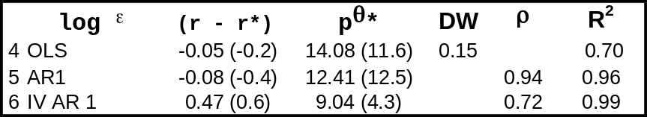
Period of estimation: 1999:1 to 2004:1. Instruments: Current and one-lagged value of the federal funds rate and of the Baa spread.

Line 1 gives OLS results. The risk premium is highly significant; the interest rate differential is wrong signed and insignificant. The residual has high serial correlation. Thus, line 2 gives results of estimation with an AR(1) correction. The risk premium remains highly significant; the interest differential is correctly signed, but insignificant.

Factors left in the error term may however affect p and by implication pθ and, to the extent that the central bank targets inflation, may also affect i. To eliminate this simultaneity bias, there are two natural instruments. The First is the U.S. federal funds rate, i*, which should be a good instrument for the interest differential; the second is the foreign investors' degree of risk aversion, θ* (the Baa spread), which should be a good instrument for pθ*. Events in Brazil are unlikely to have much effect on either of the two instruments. Line 3 presents the results of estimation using current and one lagged values of each of the two instruments. The risk premium remains highly significant. The interest rate differential remains wrong signed.

Results using the real specification are given in the bottom part of Table 2. The real exchange rate is constructed using CPI deflators. The real interest rate for the United States is constructed by using the realized CPI inflation rate over the previous six months as a measure of expected inflation. For Brazil, I constructed two different series. The First was constructed in the same way as for the United States. The second uses the fact that, since January 2000, the Brazilian Central Bank has constructed a daily forecast for inflation over the next 12 months, based on the mean of daily forecasts of a number of economists and financial market participants. These forecasts can differ markedly from lagged inflation; this was indeed the case in the wake of the large depreciation of the Real in 2002. Inflation forecasts took into account the prospective effects of the depreciation on inflation, something that retrospective measures obviously miss. Thus, the second series is constructed using the retrospective measure of inflation until December 1999, and the monthly average of the inflation forecast for each month after December 1999. The results of estimation using either of the two measures for expected inflation in Brazil are sufficiently similar that I present only the results using the second series in Table 2.

Results from lines 4 to 6 are rather similar to those in lines 1 to 3. The risk premium is highly significant. The interest rate differential is correctly signed but insignificant in the First two lines, wrong signed and insignificant in the last line.

Given the importance of the sign and the magnitude of the direct interest rate effect on the exchange rate, I have explored further whether these insignificance results for the interest differential were robust to alternative specifications, richer lag structures for the variables, or the use of other instruments. The answer is that they appear to be. Once one controls for the risk premium, it is hard to detect a consistent effect of the differential on the exchange rate.

The specification in equation (9) reflects however the theoretical shortcut taken earlier, which assumed that movements in the expected exchange rate are a constant elasticity function of movements in the current exchange rate. I have also explored a specification that does not make this assumption, and allows the exchange rate to depend on the expected exchange rate:

log(ε) = a + d E[log ε’] – b(r – r* ) + c(pθ*) + u_{ε} (10)

This equation can be estimated using the realized value of ε’ and using the same instruments as before, as they also belong to the information set at time t. The empirical problem is the usual problem of obtaining precise estimates of d versus the degree of serial correlation of the error term. To get around this problem, I present, in Figure 7, the coefficients on the interest differential and the risk premium conditional on values of d ranging from 0.8 to 1.0. For each value of d, estimation is carried out, using the real specification, with an AR(1) correction and the list of instruments listed earlier. The bands are two-standard-deviation bands. The future exchange rate is taken to be the exchange rate six months ahead. (Using the exchange rate from one month to nine months ahead makes little difference to the results. Using the exchange rate more than nine months ahead eliminates some of the months corresponding to the crisis, and thus loses a lot of the information in the sample.) The figure reports the results of estimation using the nominal exchange rate and nominal interest rate specification; results using the real specification are largely similar.

[Figure 7. Estimated effects of the risk premium and the interest rate differential on the exchange rate, as a function of the coefficient on the expected exchange rate]

The lesson from the figure is that the coefficient on the risk premium remains consistently positive. The coefficient on the interest differential is consistently wrong- signed.

In short, the empirical evidence strongly supports the First central link in our theoretical argument, the effect of the probability of default on the exchange rate. In contrast (and as is often the case in the estimation of interest parity conditions), there is little empirical support for the conventional effect of the interest rate differential effect on the exchange rate.

2.3 Estimating the default risk relation
The second relation we need to estimate is the “default risk" relation, which gives the probability of default as a function of the expected level of debt, which itself depends on the exchange rate, the interest rate, and the current level of debt, among other factors.

The relation we need to estimate is:

p = ϕ (ED’) + u_{p} (11)

where, in contrast to the theoretical model, we need to recognize the fact that next-period debt is uncertain even in the absence of default, and there may be shifts in the threshold (for example a lower threshold if a leftist government is elected), which are captured here by up.

The theory suggests assuming a distribution for the distance of next-period debt from the threshold, and using it to parameterize ϕ (.). I have not explored this, as I believe there is not enough variation in the debt-GDP ratio over the sample to allow us to estimate the position of the cumulative distribution function ϕ function precisely). So I specify and estimate a linear relation:

p = ϕ ED’ + u_{p}

Next-period's debt itself is given by the equation:

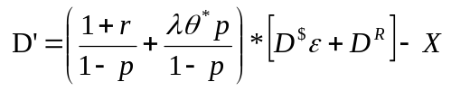

This equation does not need however to be estimated.

In estimating equation (11), I consider three different proxies for ED’ :

- The First is simply D, the current level of the net debt-GDP ratio.
That there is a strong relation between D and p is shown in Figure 8, which plots the estimated probability of default p, against the current debt-GDP ratio, for the period 1990:1 to 2004:1.
That expectations of future debt matter beyond the current level of debt is also made clear however, by the partial breakdown of the relation during the second half of 2003. Debt has stabilized, but had not decreased further. In contrast, the estimated probability of default has continued to decrease. From what we know about that period, the likely explanation seems to be the growing belief by financial markets that structural reforms, together with a steady decrease in the proportion of dollar debt, implied a better long run fiscal situation than was suggested by the current evolution of debt. For this reason, I explore two alternative measure of ED’:

[Figure 8. The relation of the estimated probability of default to the debt-GDP ratio]

- The First measure of ED’ is the mean forecast of the debt-GDP ratio one year ahead. Since January 2000, the Brazilian Central Bank has collected daily forecasts of the debt ratio for the end of the current year and for the end of the following year. Using average forecasts over the month, I construct one-year ahead forecasts of the ratio by using the appropriate weights on the current and the following end-of-year forecasts. For example the one-year ahead forecast as of February 2000 is constructed as 10/12 times the forecast for debt at the end of 2000, plus 2/12 times the forecast for debt at the end of 2001. (It turns out that, during 2003, this measure of expected debt does not move very differently from current debt, and so still does not explain the decrease in p during the second half of 2003. A forecast of debt many years ahead might do better, but such a time series does not exist.)

- The second measure of ED’ is the realized value of the debt-GDP six months ahead, instrumented by variables in the information set at time t. The results are largely similar if I use realized values from one to nine months ahead. (As for exchange rates earlier, using values more than nine months ahead eliminates important crisis months from the sample.) I shall discuss instruments below.

The results of estimation are given in Table 3.

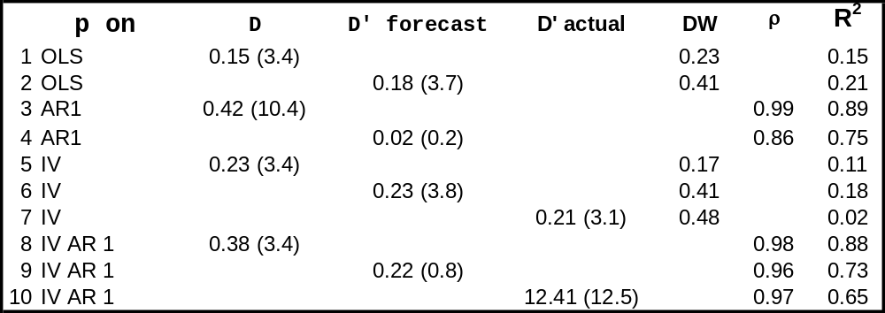
Table 3. Estimating the default risk relation
Period of estimation: 1999:1 to 2004:1. Instruments: Current and four lagged values of the Baa spread.

Lines 1 and 2 report the results of OLS regressions, using either current or forecast debt. They confirm the visual impression of a strong relation between debt and the probability of default. There is evidence of high serial correlation, so lines 3 and 4 report AR(1) results. The relation becomes stronger when current debt is used, weaker when forecast debt is used.

OLS and AR(1) results are likely however to suffer from simultaneity bias. Any factor other than debt that affects the probability of default will in turn affect expected debt. For example, financial markets may have concluded that the election of Lula would both lead to higher debt, and a higher probability of default at a given level of debt. A natural instrument here is again the Baa spread, which affects expected debt, but is unlikely to be affected by what happens in Brazil.

The same instrument can be used when using the realized value of debt six months ahead (the third measure of debt I consider), as it is in the information set at time t. The next six lines report results of estimation using the current and four lagged values of the Baa spread as instruments.

Lines 5 to 7 report the results of IV estimation, without an AR correction. The coefficients are largely similar across the three measures of debt, and significant. Lines 8 to 10 give the results of IV estimation, with an AR(1) correction. The results using the First two measures of debt are roughly unchanged by the AR(1) correction. The result of estimation using six months ahead debt (instrumented) give a negative and insignificant coefficient. It is the only negative coefficient in the table.

In short, the empirical evidence strongly supports the other central link in the theoretical model, the link from expected debt to the probability of default. This in turn implies that any factor which affects expected debt, from the interest rate to the exchange rate, to the initial level of debt, affects the probability of default.

2.4 Putting things together
Given our two estimated relations, we can determine whether and when an increase in the domestic interest rate will lead to an appreciation - through the conventional interest rate channel - or, instead, to a depreciation - through its effect on the probability of default.

In a way, we already have the answer, at least as to the sign. In most of the specifications of the capital flow relation, we found the effect of the interest rate differential to be either wrong signed, or correctly signed but insignificant. If this is the case, only the second channel remains, and an increase in the interest rate will always lead to a depreciation...

So, to give a chance to both channels, I use, for the capital flow equation, the specification which gives the strongest correctly signed effect of the interest rate on the exchange rate, line 2 of Table 2:

log ε = constant – 0.21(r – r*) + 12.43 (θ*p)

For the default risk equation, I use line 6 of Table 3, which is representative of the results in the table:

p = constant + 0.23 ED’
= constant + 0.23 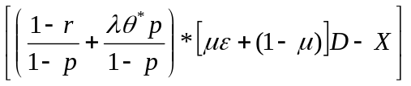

- The direct effect of an increase in the interest rate on the exchange rate is given by the coefficient on (r – r*). Thus, given the probability of default, an increase in the Selic of 100 basis points leads to an appreciation of 21 basis points.

- The increase in the interest rate however also leads to an increase in expected debt, and thus to an increase in the probability of default, which leads to a depreciation.
The strength of this indirect effect depends on the risk aversion of foreign investors, θ*; the initial debt-GDP ratio, D, and its composition, μ; the relation between the market and foreign investors' risk aversion, λ.
For the First three parameters, I use as benchmark values the average values of these three variables for the period 1999:1 to 2004:1: D = 0.53; μ = 0.50, and θ* = 0.56. For the last, I use a value of λ = 0.50 (While one may choose a different value, it turns out that the specific value of λ does not have much effect on the results.)
Under these assumptions, the equations above imply an indirect effect on the exchange rate of 279 basis points. The net effect of an increase in the interest rate of 100 basis points is therefore to lead to a depreciation of 258 basis points.

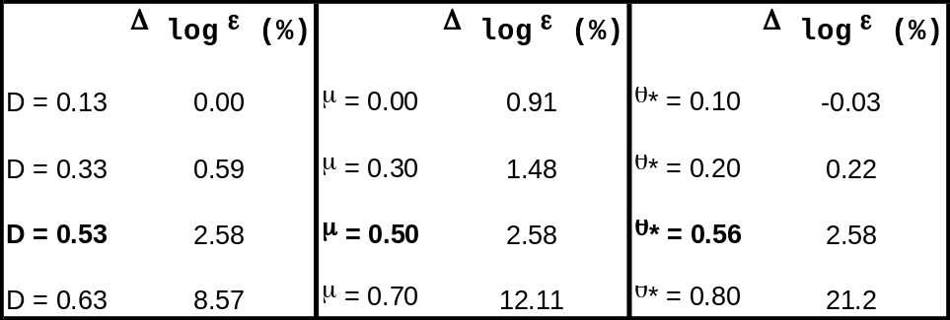
Table 4. Effects of an increase in the Selic of 1 percentage point on the exchange rate, for different values of D; μ and θ*
Table 4 gives a sense of the sensitivity of the effect to values of D; μ and θ*. Benchmark values are boldfaced.

- The First set of columns show the effects of different initial debt levels (keeping the other parameters equal to their benchmark values)
For debt-GDP ratios of 13%, the effect of an increase in the interest rate on the exchange rate is roughly equal to zero: The direct and indirect effects roughly cancel. The indirect effect rapidly increases with the debt ratio. With a debt ratio of 63%, the effect of a one percentage point in the interest rate is a depreciation of 8.57%. For debt ratios above 70%, we are in the case discussed in the theoretical section, where there is no longer an equilibrium. The interactions between the probability of default and the debt are too strong. (This may explain the high volatility in the EMBI and the nervousness of foreign investors in 2002.)

- The next two columns show the effects of different proportions of dollar-denominated debt (keeping the other parameters equal to their benchmark value). With no dollar-denominated debt, the exchange rate barely moves in response to the interest rate. As the proportion increases however, the effect increases rapidly. For μ = 0:7, the depreciation reaches 12.11%. And for values above 0.8, there is no longer an equilibrium. The fact that the Brazilian government has steadily reduced μ in 2003 may help explain why the estimated probability of default decreased steadily while the level of debt remained relatively high.

- The last two columns show the effect of different degrees of risk aversion on the part of foreign investors. For low risk aversion, the exchange rate actually appreciates, but by very little. But, again, as the degree of risk aversion increases, the exchange rate depreciates. As risk aversion reaches 0.8, the depreciation reaches 21.2%. And for risk aversion slightly higher than 0.8, the equilibrium again disappears.

- Conclusions and extensions

The model and the empirical work presented in this paper yield a clear conclusion. When fiscal conditions are wrong - i.e. when debt is high, when a high proportion of debt is denominated in foreign currency, when the risk aversion of investors is high - an increase in the interest rate is more likely to lead to a depreciation than to an appreciation. And fiscal conditions were indeed probably wrong, in this specific sense, in Brazil in 2002.

The limits of the argument should be clear as well. To go from this model and these conclusions to a characterization of optimal monetary and fiscal policy in such an environment requires a number of additional steps:

- The model should be made dynamic. The same basic mechanisms will be at work. But this will allow for a more accurate mapping from the model to the data. In a dynamic model, the probability of default will depend on the distribution of the future path of debt, not just \next-period debt".
- The model needs to be nested in a model with an explicit treatment of nominal rigidities. This is needed for two reasons: To justify the assumption that the central bank has indeed control of the real interest rate; and to derive the effect of changes in the real exchange rate on inflation.
- The model focused on the effects of the interest rate on inflation through the real exchange rate. There is obviously another and more conventional channel through which an increase in the interest rate affects inflation, namely through the effect of the interest rate on demand, output, and in turn, inflation.
When and whether this second channel dominates the First is an empirical issue. I speculate that, in the case of Brazil, this second channel may not be very strong. The safe real interest rate has been very high over the last three or four years, remaining consistently above 10%. The real rate at which firms and consumers can borrow has been much higher than the safe real rate, averaging 30 to 40% over the same period. At that rate, few firms and consumers borrow, and the demand from those who borrow may not be very elastic. In effect, the main borrower in the economy is the government, and the effect of the interest rate may fall primarily on fiscal dynamics. The issue however can only be settled by extending the model and estimating the strength of the different channels.

Turning to another set of issues: The paper has not characterized the monetary policy which was actually followed in Brazil in 2002-2003... While not central to the argument developed in this paper - which is about a mechanism rather than an episode - this is of interest in itself, and it helps to understand the behavior of a central bank in such an environment.

To give a sense of policy during that period, and given that the main instrument of monetary policy is the Selic rate, Figure 9 plots forecast inflation and the real interest rate over the period 2002:1 2004:1. Forecast inflation is the mean forecast of CPI inflation over the following 12 months, described earlier. The real interest rate is constructed by subtracting forecast inflation from the Selic rate.

The figure tells a clear story. Until september 2002, forecast inflation remained low, and the Central Bank continued its policy of allowing for a slow decrease in the Selic rate, both nominal and real. As the currency depreciated further and forecast inflation increased, the Central Bank increased the Selic rate, First in October (before the elections), and then again in November and December. These increases were smaller however than the increase in the inflation forecast, leading to a further small decline in the real interest rate. This changed, starting in early 2003. Troughout the First half of the year, increases in the Selic combined with a steady decrease in the inflation forecast combined to lead to a large increase in the real interest rate, from 10% in late 2002 to 18% in mid-2003. Since then, decreases in the Selic have led to a steady decrease in the real interest rate, which is now close to 10%, its 2002 low.

Why did the Central Bank allow for a decrease in the real rate until the end of 2002, before increasing the real rate strongly during the First half of 2003? The rationale explored in this paper, the effect of higher real rates on fiscal dynamics, may have played a role. The reluctance to take an unpopular measure in the middle of an electoral campaign may have been another factor - although the first increase in the Selic took place before the election. The rationale given by the Central Bank itself is its initial belief that inflation would turn around faster, and its subsequent realization that tighter monetary policy was needed to achieve lower inflation in 2003 (Banco Central do Brazil, 2003).

Whatever the reasons, it is therefore the case that, in contrast to the conceptual experiment discussed in the paper, monetary policy did not lead to a higher real interest rate in 2002. By the time the real interest rate was indeed increased, in 2003, the commitment to fiscal austerity by the new government probably dominated any potentially perverse effects of higher real interest rates on debt dynamics.

References:

[1] Banco Central do Brazil. Open letter from the governor of the central bank to the minister of ¯nance. January 2003. Brazilia.
[2] Ricardo Caballero and Arvind Krishnamurthy. A dual liquidity model for emerging markets. January 2002. mimeo, MIT.
[3] Eliana Cardoso. Brazil: Macropolicies in the early 2000s. 2004. mimeo.
[4] Arminio Fraga, Ilan Goldfajn, and Andr¶e Minella. Inflation targeting in emerging market economies. March 2003. forthcoming, NBER Macroeconomics.
[5] Eduardo Loyo. Tight money paradox on the loose: A fiscalist hyperinflation. June 1999. mimeo, JFK School of Government, Harvard University.
[6] Affonso Pastore and Maria Pinotti. Fiscal policy, inflation, and the balance of payments. December 2003. mimeo.
[7] Javier Santiso. Wall Street and emerging democracies; Financial markets and the Brazilian presidential elections. February 2004. mimeo, BBVA.
[8] Thomas Sargent and Neil Wallace. Some unpleasant monetarist arithmetic. Federal Reserve Bank of Minneapolis Quarterly Review, 5:1{17, 1981.
[9] Michael Woodford. Interest and Prices. Princeton University Press, Princeton, 2003.

The variance is given by V≡ p(1 - p)(1 + r^{R})². So, using equation (1) with pV replacing pθ, the variance is implicitly defined by V (1 - p) = p((1 + r) + θV)², and depends on p; r and θ. For small values of p however, say p less than 0.2, V ≈ p.
. Whether sharp changes in capital flows (the so called “sudden stops”) actually reflect changes in risk aversion on the part of foreign investors, or other factors (factors generally referred to as “liquidity”) is not important here (for an approach based on liquidity shocks, see for example Caballero and Krishnamurthy [2002].) All these can be captured by changes in θ*. What is important is that these shifts affect foreign investors more than the average investor in the market.
If C(.) and N(:) are linear, then the locus is convex. I draw it as convex, but the results below do not depend on convexity.
In this case, the convexity and concavity of the two loci suggest the potential existence of another equilibrium with higher p and ². I have not looked at the conditions under which such an equilibrium exists or not. I suspect that, again, if it does, it has unappealing comparative statics properties.
For readers wanting more background, two useful descriptions and analyses of events in 2002 and 2003 are given by Pastore and Pinotti [2003] and Cardoso [2004]. For an insightful analysis of the mood and the actions of foreign investors, see Santiso [2004].
This definition turns out to be more convenient than the conventional EMBI spread. For empirically relevant values of r$, the two move closely together.
Capital flows can be expressed as a function of the real exchange rate and real interest rates, or as a function of the nominal exchange rate and nominal interest rates. But the trade balance is a function of the real exchange rate. Thus, the nominal specification is, stricto sensu, incorrect.
Note that p and θ* are uncorrelated by construction. But pθ* and θ* are correlated.
The proportion of dollar debt, net of swap positions, has decreased from 37% in December 2002 to 21% in January 2004.
The reader may wonder how the Baa spread can be used as an instrument in both the capital flow and the default risk equations. It is because it enters multiplicatively (as θ* in pθ*) in the capital flow equation, and can therefore be used as an instrument for pθ* in that equation.

